## 

horizontal line

**Mono Apartments - System Changes - 11/05/23**

March 2023

—

Prepared for Modern Nomads Group Pty Ltd

Yudo Baskaro, Director of the company

# Mono System Changes after 08/05/23 Meeting.

Link to Site with changes: <https://production.u22s2110.monash-ie.me>

1. Contractor Views Inspection details before accepting
   1. Contractor clicks inspection view.

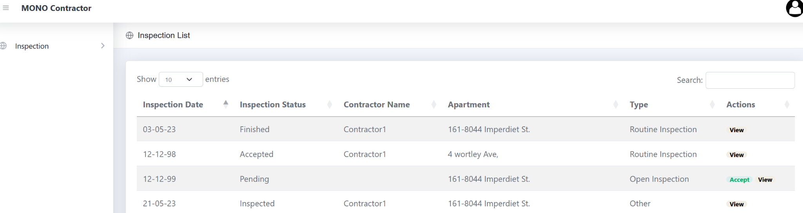

* 1. Contractor views typical details and the inspection description as noted by the admin staff.
     1. Can include any text or images that might be necessary. Once the Contractor accepts the inspection and undertakes it, they can choose to leave this information or remove it and replace it with the inspection content.
     2. Also allows the contractor to accept the inspection in this view.

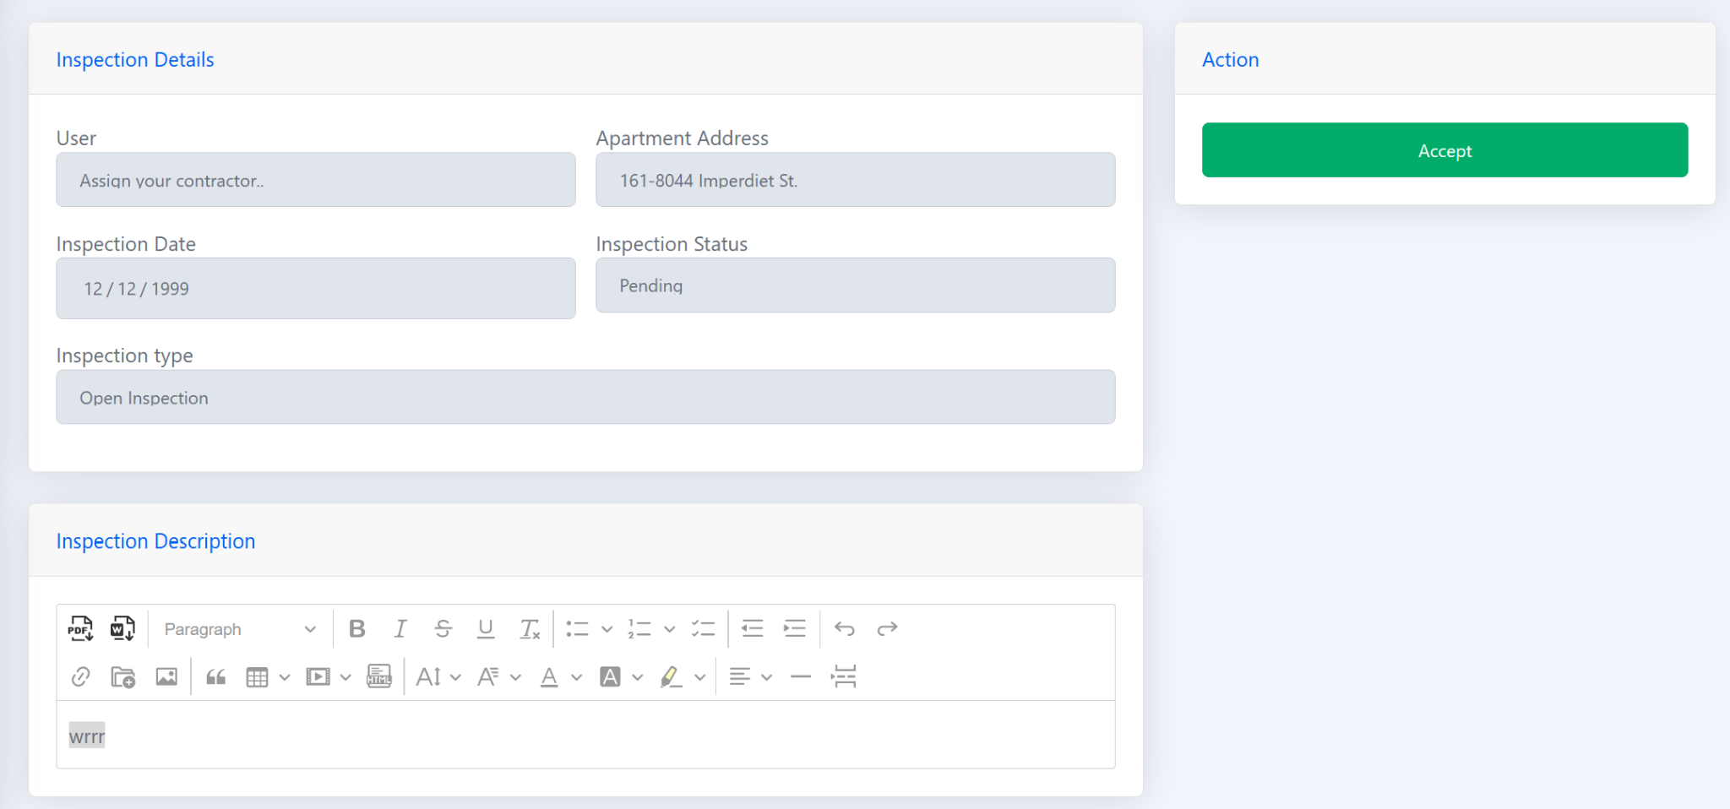

1. Send a Query related to an Inspection
   1. Send a query/email whilst undertaking an inspection.

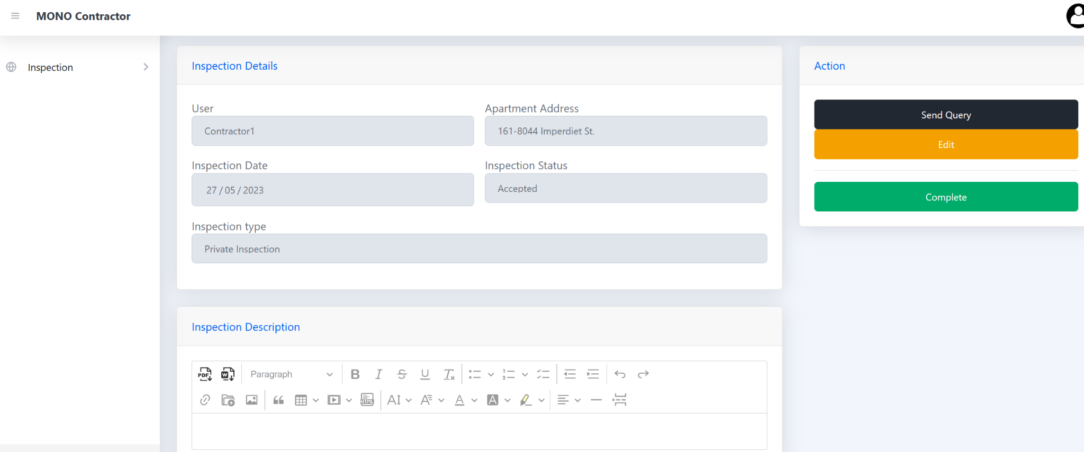

* 1. View of sending a query

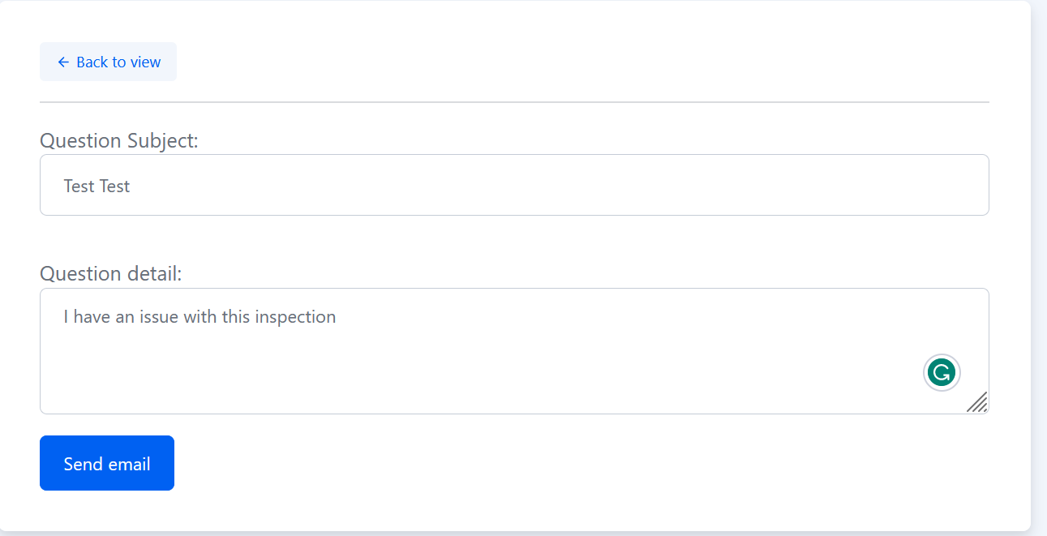

**Admin View of Contractors sent query**

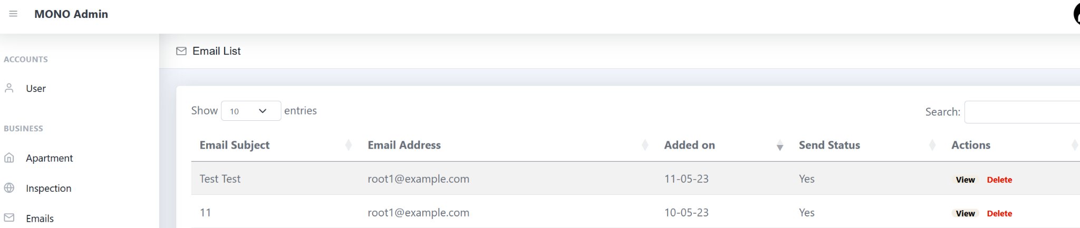

* 1. Email view of what the admin receives when a contractor sends a query.
     1. Email View

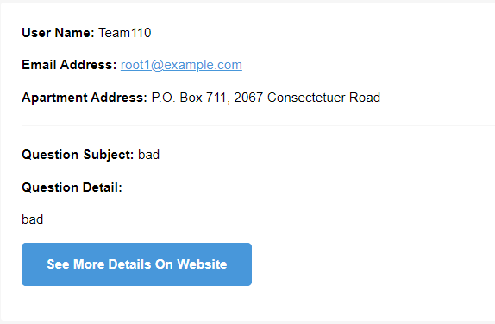

* + 1. Site view

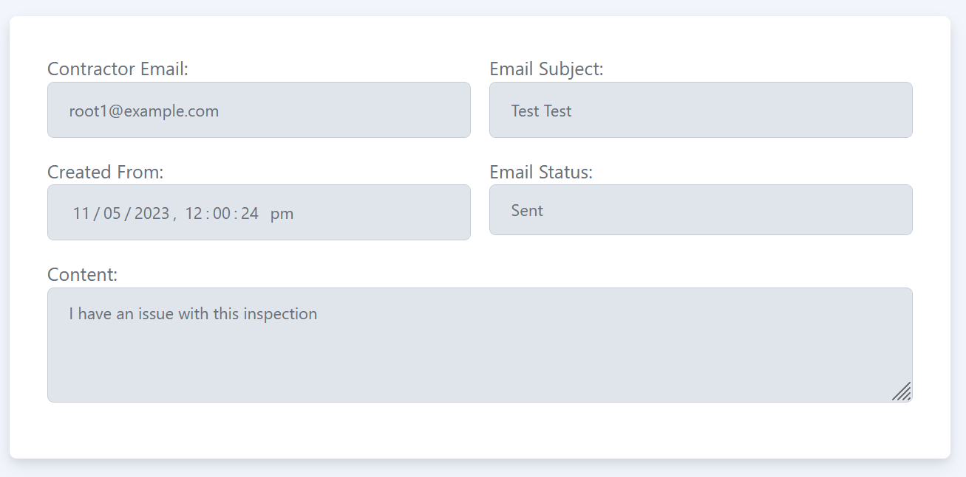

1. Rejecting a Job
   1. Admin wants to reject an inspection.

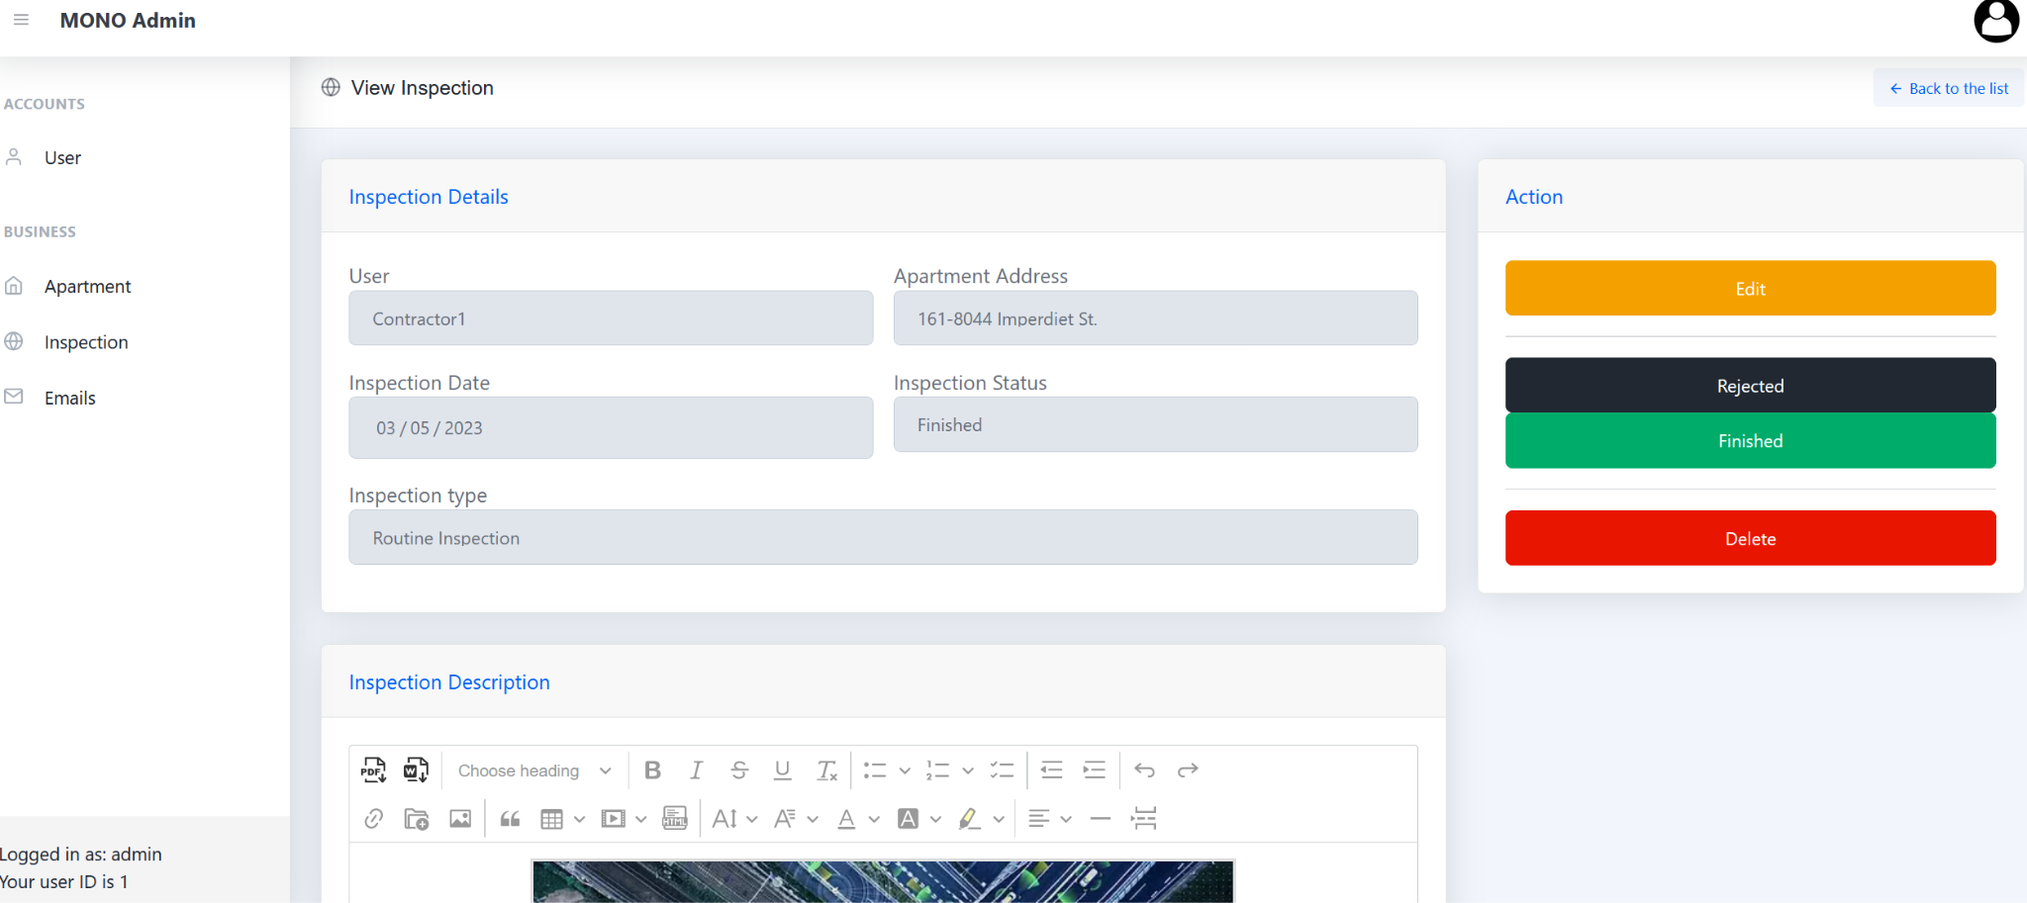

* 1. Send Email notifying a contractor that the job has been rejected.

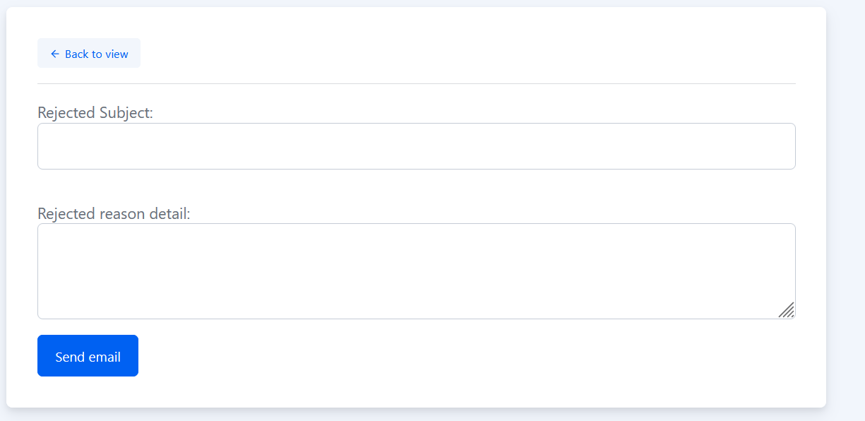

* 1. Contractor View of Rejected Job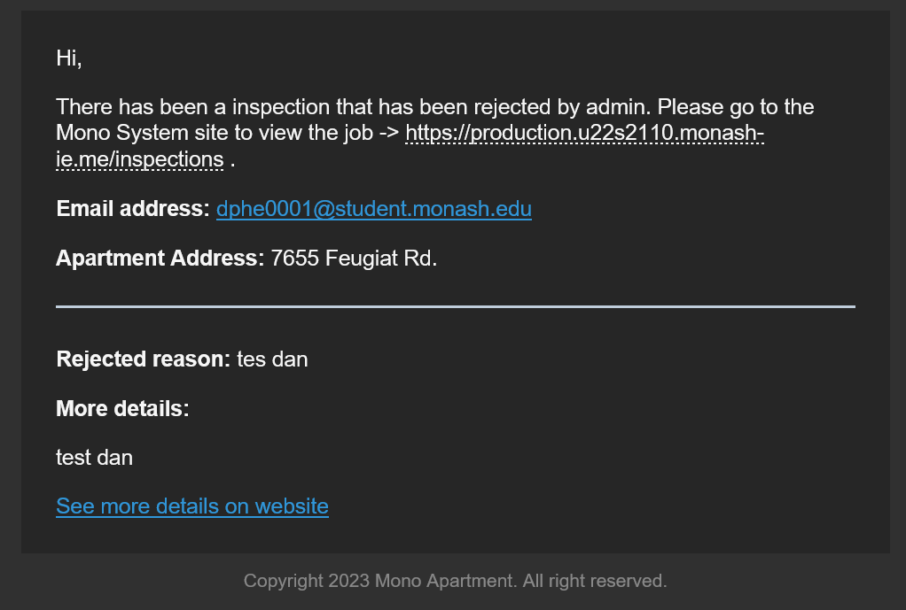

1. Edit Notification:
   1. This functionality notifies a contractor that an inspection has been edited by an admin, showcasing changed details.

